**Learning from home - BKSB for Students**

Step 1) Search Middlesbrough College via **Google Chrome** and click on the web page link.

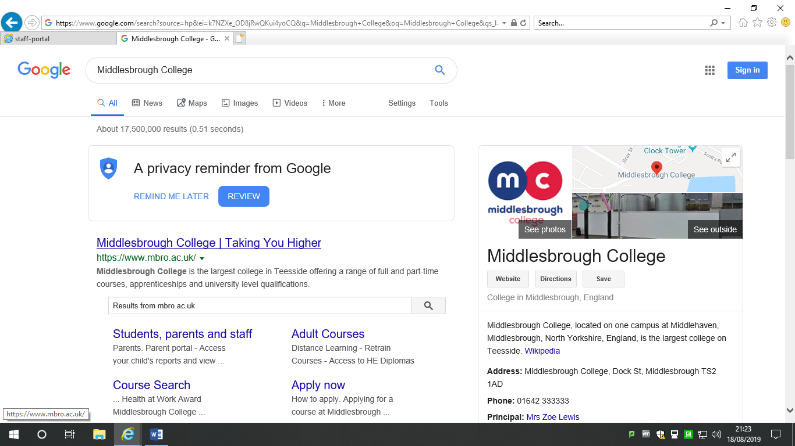

Click to access college Website: <https://www.mbro.ac.uk/>

Step 2: Click on the **‘Student, parents and staff’** link at the top right of the screen.

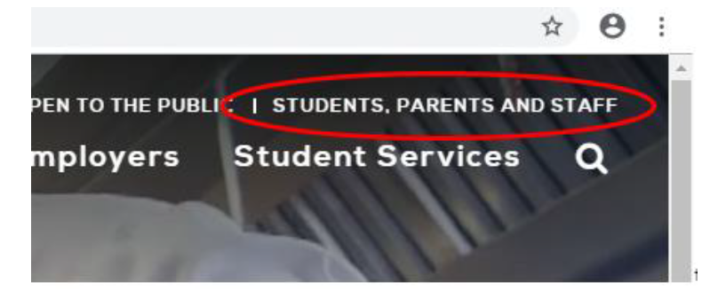

Step 3: Click on the **BKSB** link.

Login details are your **student or staff ‘M’ number** and either the default password (“password”) or the password you have set.



Step 4: Click the **FOCUS Functional Skills** link to access your English/maths course.



Step 5: Click on ‘**View Course’** to either access your initial assessment start or view your skills building activities.

*In the majority of cases, staff should complete (Legacy) and students should compete (Reforms)*

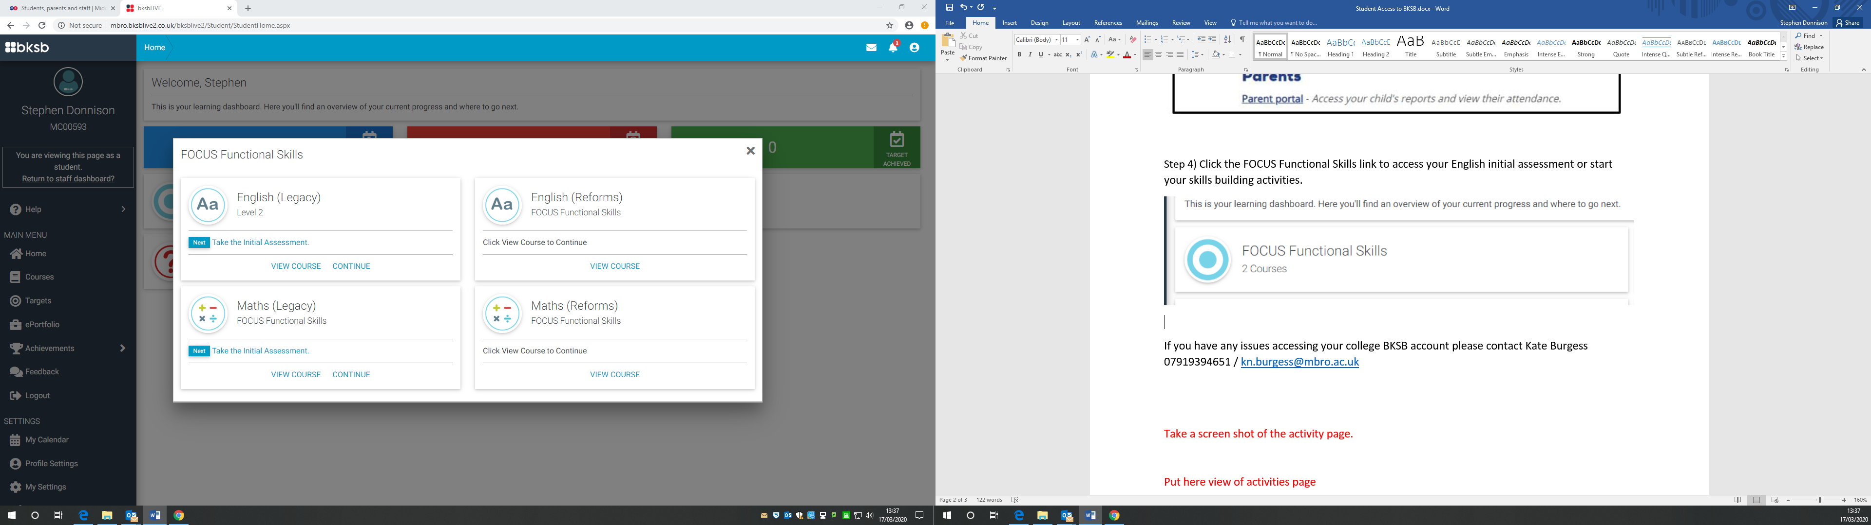

Step 6: Select by clicking the **resource** you would like to work on to improve.

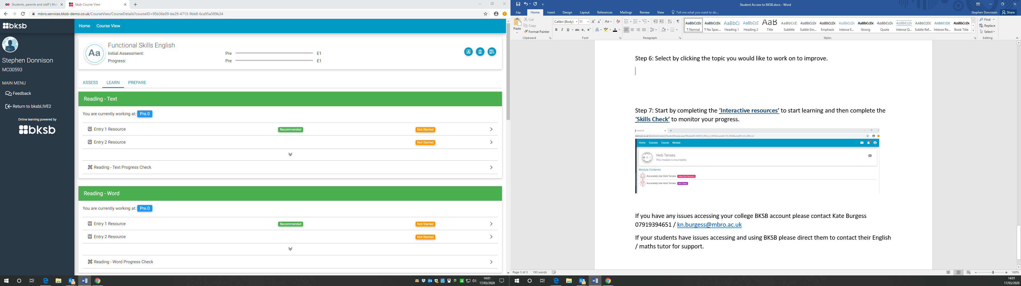

Step 7: Start by completing the **Interactive resources** to start learning and then complete the **Skills Check** to monitor your progress.

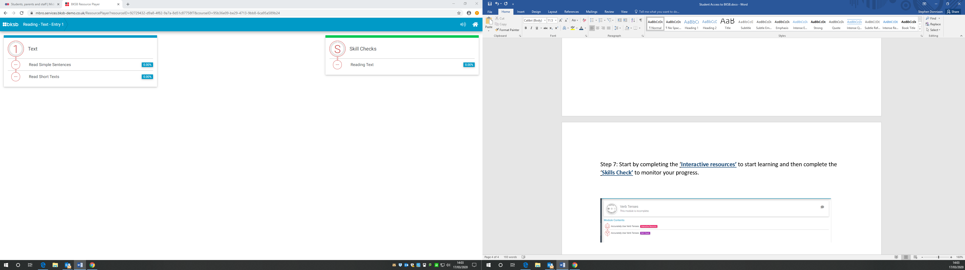

If you are experiencing issues accessing and using BKSB please contact the college’s Facilities Services Helpdesk - [Helpdesk@mbro.ac.uk](mailto:Helpdesk@mbro.ac.uk) or 01642 333259.